
A 10

Sreenidhi Institute of Science & Technology
(An Autonomous Institution)
Code No: 101ME02

B. TECH. I – Year II – Semester Examinations, June/July, 2012 (Suppli.-AN)
ENGINEERING DRAWING - II ( Common to all branches )

Time: 3 Hours Max. Marks : 70

Note : No additional answer sheets will be provided.

Part-A (Objective Type)
Max.Marks:20

Answer all QUESTIONS.

1. Define reduced scale and enlarged scale.
2. What is meant by scale factor?
3. Explain briefly, the different methods of development.
4. What are the uses of development of surfaces?
5. Explain advantages of "Isometric projections".
6. What is an isometric view and isometric scale?
7. Compare first angle and third angle projection methods.
8. Sketch the symbols used for
i) First angle projection ii) third angle projection.
9. Explain the principle of perspective projection.
10. What are the various methods of drawing a perspective view?
Part – B
Max. Marks: 50

ANSWER ANY FIVE QUESTIONS. EACH QUESTION CARRIES 10 MARKS.

1. A vertical square prism, base 50 mm side is completely penetrated by a horizontal square prism, base 24 mm side so that their axes are 6 mm apart. The axis of horizontal prism is parallel to the VP, while the faCES of both prisms are equally inclined to the VP. Draw the projections of the prisms showing lines of intersection.
2. A cylindrical pipe of 30mm diameter has a similar branch of the same size. The axis of the main pipe is vertical and is intersected by that of the branch at right - angles. Draw the projections of the pipes, assuming suitable lengths, when the two axes lie in a plane parallel to the V.P. Develop the surfaces of the two pipes.

3. A verticial cylinder of 60 mm diameter has a square hole of 30 mm sides cut through it. The axis of the hole is horizontal, parallel to the VP and 6 mm away from the axis of the cylinder. The faces of the hole are equally inclined to the H.P. and V.P. Draw the projections of the cylinder showing the hole in it.
4. A Hexagonal prism having the side of base 30 mm and the height of 70 mm is resting on one of the corner of the base and its axis is inclined to 30⁰ to the H.P. Draw its projections and also prepare the isometric view of the prism in the above stated condition.
5. Draw the following views of the block shown in below figure. Use first angle projection method.
i) Front view, ii) Top view iii) both side views.
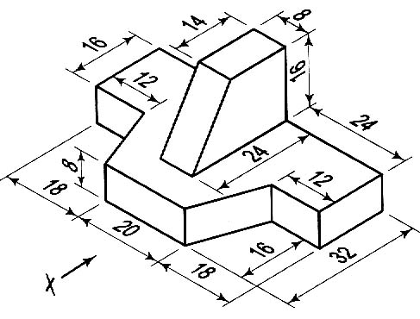
6. A point A is situated 1.5 cm behind the picture plane and 1 cm above the ground plane. The station point is 2.5 cm in-front of the picture plane, 2 cm above the ground plane and lies in a central plane, 1 cm to the right of the point. Draw the perspective view of the point A.
7. What are the various processes which can be performed by use of computer in the drafting process?
8. What all the benefits and limitations of CAD?

-- 00 -- 00 --

